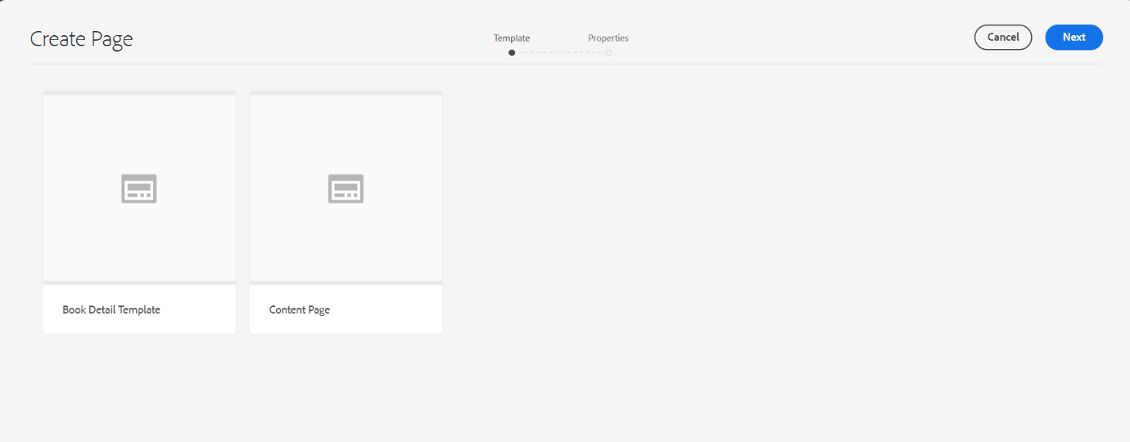This is the book detail template:

10 Book Pages Using the Template:

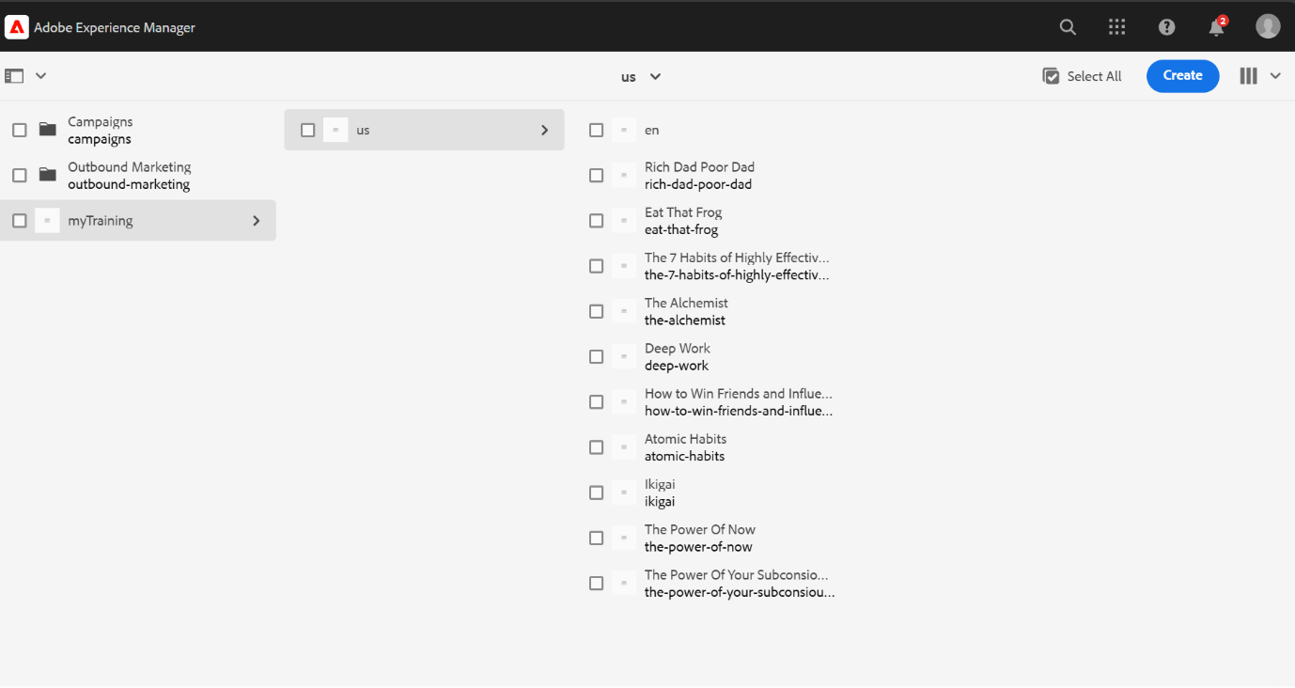

Header Component:

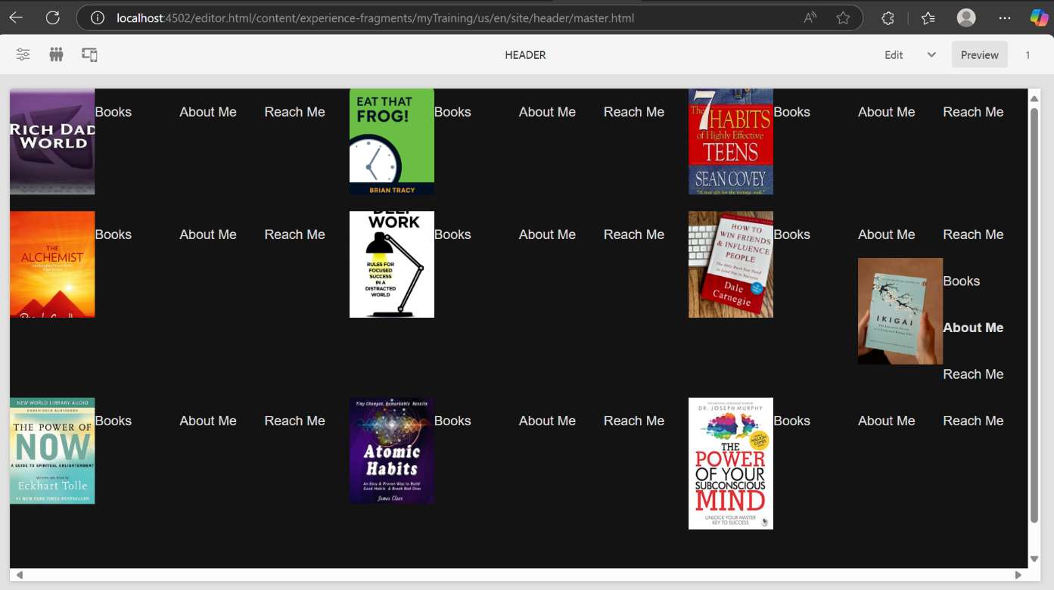

Footer Component:

>If the user clicks on any book name in the footer, it will show the corresponding book details with an image.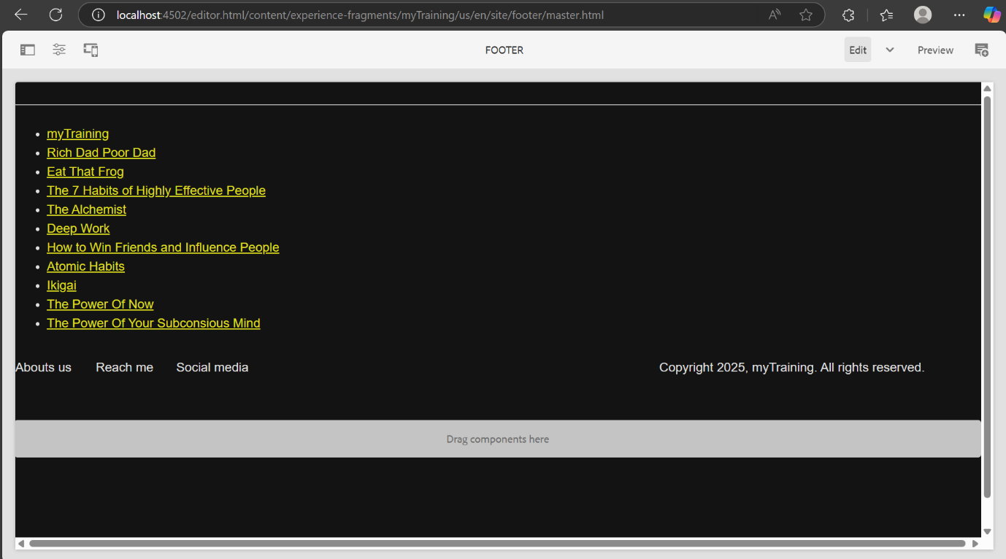

These are the **Atomic Habits** book details:

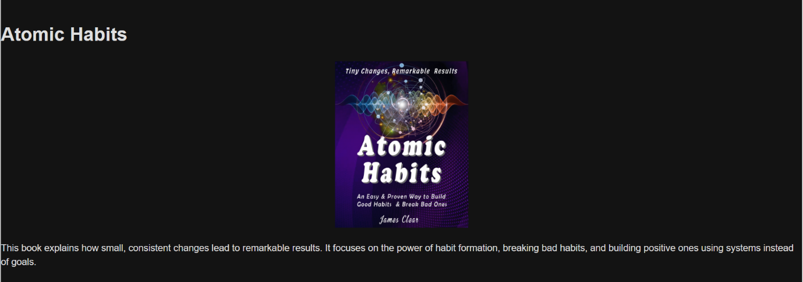

These are the **Ikigai** book details.

